SIMATS ENGINEERING (SAVEETHA SCHOOL OF ENGINEERING)
Department of Computer Science and Engineering
CO2_AT1 — CHART CONSTRUCTION TEST

Course Code: | DSA06 | Course Title: | Data Handling and Visualization
CO Assessed: | CO2 – Construction (BL3) | Assessment: | Assessment Tool 1 – Chart Construction
Weightage: | 20% of CIA | Total Marks: | 25 (5 Questions × 5 Marks)
CO2 Statement: | Apply appropriate chart construction techniques — correct chart type, axes, scales, and calculations — to accurately represent given data.(BL3)
Student Name: | Sania Herbert | Reg. No.: | 192324062
Section / Batch: | 2023/AI&DS | Date: | 09.08.26

Code of Conduct
I Sania Herbert (192324062) certify that this submission is my original work and that I have adhered to the guidelines specified for this assessment. I understand that any violation of academic integrity rules will result in disciplinary action.

Signature of the Student: Sania

Instructions
- This test contains 5 questions, each carrying 5 marks. Total: 25 Marks.
- No negative marking. Unanswered questions carry zero marks.
- No calculators or electronic devices permitted.
- Duration: 75 minutes.
- Graph paper or a ruler is recommended for accurate, to-scale drawing.
- Show all calculations (e.g., percentages, angles, bin ranges, five-number summaries) as part of your answer.
- Every chart must include a title, correctly labeled axes, and a legend where applicable.

Annexure A – CHART CONSTRUCTION

Rubrics for Calculation ASSESSMENT RUBRIC
AT1 — Chart Construction Test
CO2 · BT3: Apply ·
This rubric is used to assess student responses to the CO2-AT1 Chart Construction Test, in which students are given a small dataset and must construct an accurate, correctly labeled chart of a specified type.

Criteria | Weightage | Level 4 – Exemplary | Level 3 – Proficient | Level 2 – Developing | Level 1 – Beginning
Understanding of Concepts | 25% | Demonstrates thorough, accurate understanding of the correct chart type, and the axes, scale, and elements required to construct it for the given data. | Good understanding of the required chart type and construction elements, with only minor gaps. | Basic understanding of chart construction, but with some misconceptions about the correct chart type, axes, or scale. | Poor understanding of core construction concepts; selects a chart type or elements fundamentally unsuited to the data.
Explanation | 25% | Shows detailed, clearly worked calculations (e.g., angles, bin ranges, five-number summary) and explains each construction step. | Shows clear calculations and construction steps, with adequate explanation for most parts. | Calculations or construction steps are shown but incomplete, or explanations are superficial. | Little or no working shown; calculations and construction steps are missing or unexplained.
Application | 20% | Effectively applies chart construction techniques to produce a complete, accurate chart correctly matched to the data. | Applies construction techniques to produce a correct chart, with only minor errors. | Limited application of construction techniques; the chart partially represents the data but has notable errors. | Fails to apply appropriate construction techniques; the chart does not correctly represent the data.
Organization | 15% | The chart is neatly and logically constructed, with a title, correctly labeled axes, a legend where applicable, and elements in a clear order. | The chart is well organized, with only minor issues in labeling, legend, or layout. | Basic construction; required elements (title, axes, legend) are present but poorly arranged or partly missing. | Poorly constructed; the chart is missing key elements such as a title, axis labels, or a legend.
Accuracy | 10% | The chart is completely accurate — all values, proportions, scales, and calculations correctly match the given data. | Mostly accurate, with only minor omissions or a small error in one value or calculation. | Partially correct; some plotted values, proportions, or calculations are missing or incorrect. | Largely inaccurate; major errors in plotted values, proportions, or calculations relative to the given data.

Scoring Guide
For each criterion, award a performance level (1–4) based on the descriptors above. Multiply the level achieved (as a percentage of 4, i.e., Level 4 = 100%, Level 3 = 75%, Level 2 = 50%, Level 1 = 25%) by the criterion's weightage, then sum across all five criteria to obtain the total score out of 100%.

Faculty In-charge | Course Coordinator | Head of Department
Signature: _______________ | Signature: _______________ | Signature: _______________
Date: ___________________ | Date: ___________________ | Date: ___________________

Problem 21
Choropleth-Style Grid Map (5 Marks)
Data: Sales index by region: North=80, South=45, East=95, West=60, Central=70.
Task: Construct a simplified choropleth-style grid map, applying a sequential color scale from light
(lowest index) to dark (highest index) across the five regions.
Dataset:
Region | Sales Index
North | 80
South | 45
East | 95
West | 60
Central | 70

Tableau steps
- Open Tableau → Connect → Microsoft Excel.
- Load your data.
- Create a new worksheet.
- Drag Region → Columns.
- Drag Sales Index → Color.
- Change Marks to Square.
- Drag Region → Label.
- Drag Sales Index → Label.
- Click Color → Edit Colors.
Select a sequential color palette.
Choose a light-to-dark palette.
Make sure:
- South (45) = lightest
- West (60)
- Central (70)
- North (80)
- East (95) = darkest
Important calculation
Minimum:45
Maximum:95
So the color intensity follows:
45 → 60 → 70 → 80 → 95
Light → Dark
Note: Because these five regions don't contain latitude/longitude or actual geographic boundaries, this is a choropleth-style grid, not a true geographic choropleth map.
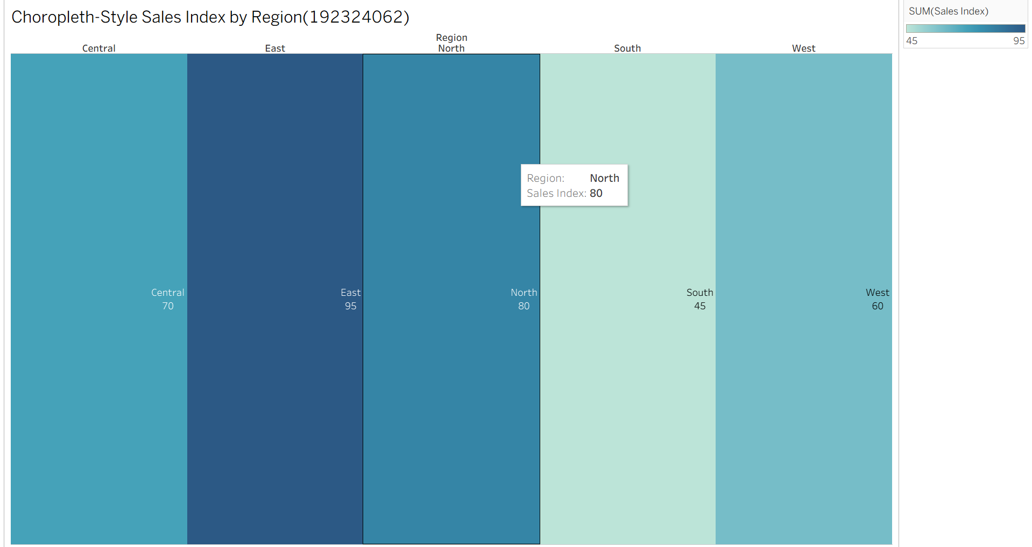

Problem 22
Diverging Color Scale — Profit/Loss (5 Marks)
Data: Monthly profit/loss ($'000): Jan=−15, Feb=+8, Mar=−3, Apr=+22, May=+5, Jun=−10.
Task: Construct a bar chart using a diverging color scale (e.g., one color for loss, another for profit) to
represent this data, clearly marking the zero baseline.

Dataset:
Month | Profit/Loss ($000)
Jan | -15
Feb | 8
Mar | -3
Apr | 22
May | 5
Jun | -10

Tableau steps
- Create a new worksheet.
- Drag Month → Columns.
- Drag Profit/Loss → Rows.
- Set Marks → Bar.
- Drag Profit/Loss → Color.
- Click Color → Edit Colors.
- Select a Diverging palette.
- Set the midpoint to 0.
- Use:
  - Negative → loss color
  - Positive → profit color
- Right-click the y-axis → make sure Include Zero is enabled.
- Drag Profit/Loss → Label.
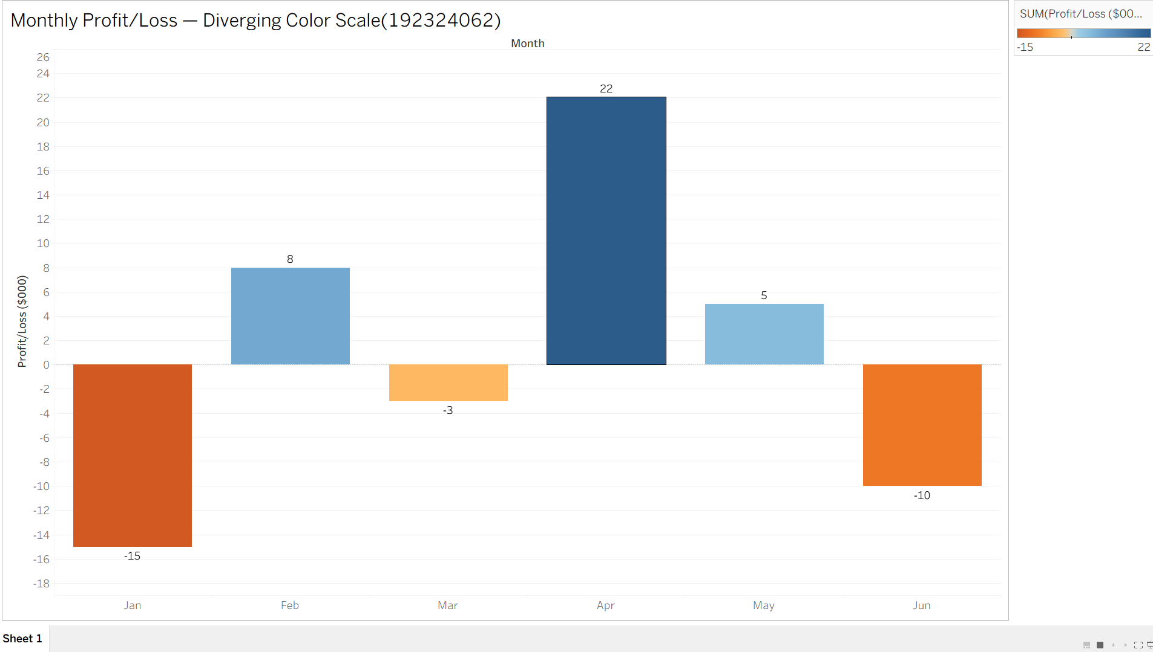

Problem 23
Treemap — Proportional Area (5 Marks)
Data: Revenue by product category: Electronics=$400K, Clothing=$250K, Books=$150K, Toys=$100K,
Home=$100K.
Task: Construct a treemap where each rectangle's area is proportional to that category's share of total
revenue. Show your calculation of each category's percentage share.

Data
Product Category | Revenue ($K)
Electronics | 400
Clothing | 250
Books | 150
Toys | 100
Home | 100
Step 1 — Total revenue
Step 2 — Percentage calculation
Formula:
Category | Revenue | Calculation | Share
Electronics | 400K | 400/1000 × 100 | 40%
Clothing | 250K | 250/1000 × 100 | 25%
Books | 150K | 150/1000 × 100 | 15%
Toys | 100K | 100/1000 × 100 | 10%
Home | 100K | 100/1000 × 100 | 10%
Total | 1000K |  | 100%
Tableau steps
- Create a new worksheet.
- Change Marks to Treemap.
- Drag Product Category → Label.
- Drag Revenue → Size.
- Drag Product Category → Color.
- Drag Revenue → Label.
- Click Label → Edit Label.
- Display:
  - Category
  - Revenue
  - Percentage of total
To calculate percentage in Tableau
Right-click the Revenue pill used for Label.
Select:
Quick Table Calculation → Percent of Total
You should get:
Electronics 40%
Clothing 25%
Books 15%
Toys 10%
Home 10%

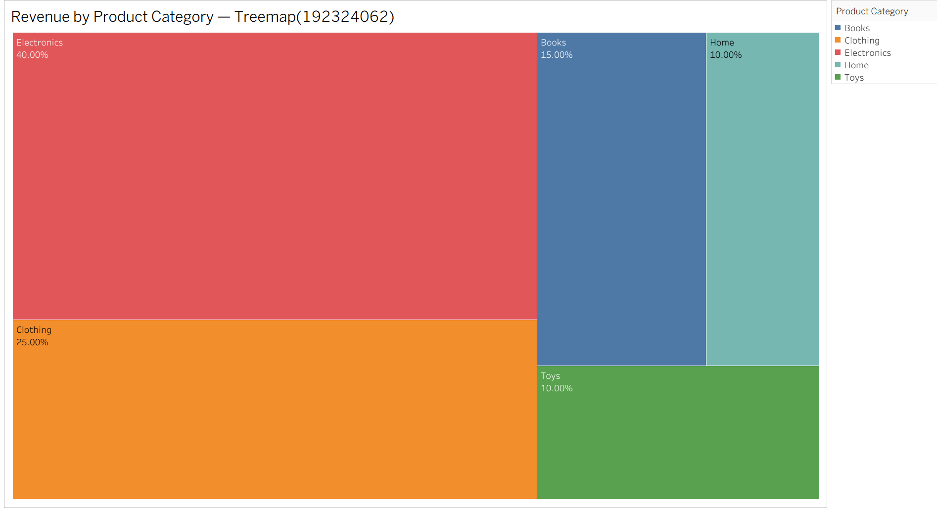

Problem 24:
Combination Chart — Bar + Line (5 Marks)
Data: Monthly sales (units) and average price ($): Jan=(100,20), Feb=(120,22), Mar=(90,25),
Apr=(150,21), May=(130,23), Jun=(160,24).
Task: Construct a chart combining a bar chart (units sold) with a line chart (average price) across the six
months. Explain why you would avoid using a dual y-axis and how you would represent both variables
clearly instead.

Month | Sales Units | Average Price ($)
Jan | 100 | 20
Feb | 120 | 22
Mar | 90 | 25
Apr | 150 | 21
May | 130 | 23
Jun | 160 | 24
Step 1 — Create calculated field for Sales Index
In Tableau:
Analysis → Create Calculated Field
Name:
Sales Index
Formula:
([Sales Units] - 90) / (160 - 90) * 100
Step 2 — Create calculated field for Price Index
Name:
Price Index
Formula:
([Average Price] - 20) / (25 - 20) * 100
Result
Month | Sales | Price | Sales Index |  | Price Index
Jan | 100 | 20 | 14.29 | 0
Feb | 120 | 22 | 42.86 | 40
Mar | 90 | 25 | 0 | 100
Apr | 150 | 21 | 85.71 | 20
May | 130 | 23 | 57.14 | 60
Jun | 160 | 24 | 100 | 80
Tableau construction
- Drag Month → Columns.
- Drag Sales Index → Rows.
- Change Marks to Bar.
- Drag Price Index onto the existing chart.
- Change the second Marks card to Line.
- Keep both on the same y-axis scale.
- Do not select Dual Axis.
Your chart will contain:
Bars → Sales Index
Line → Price Index
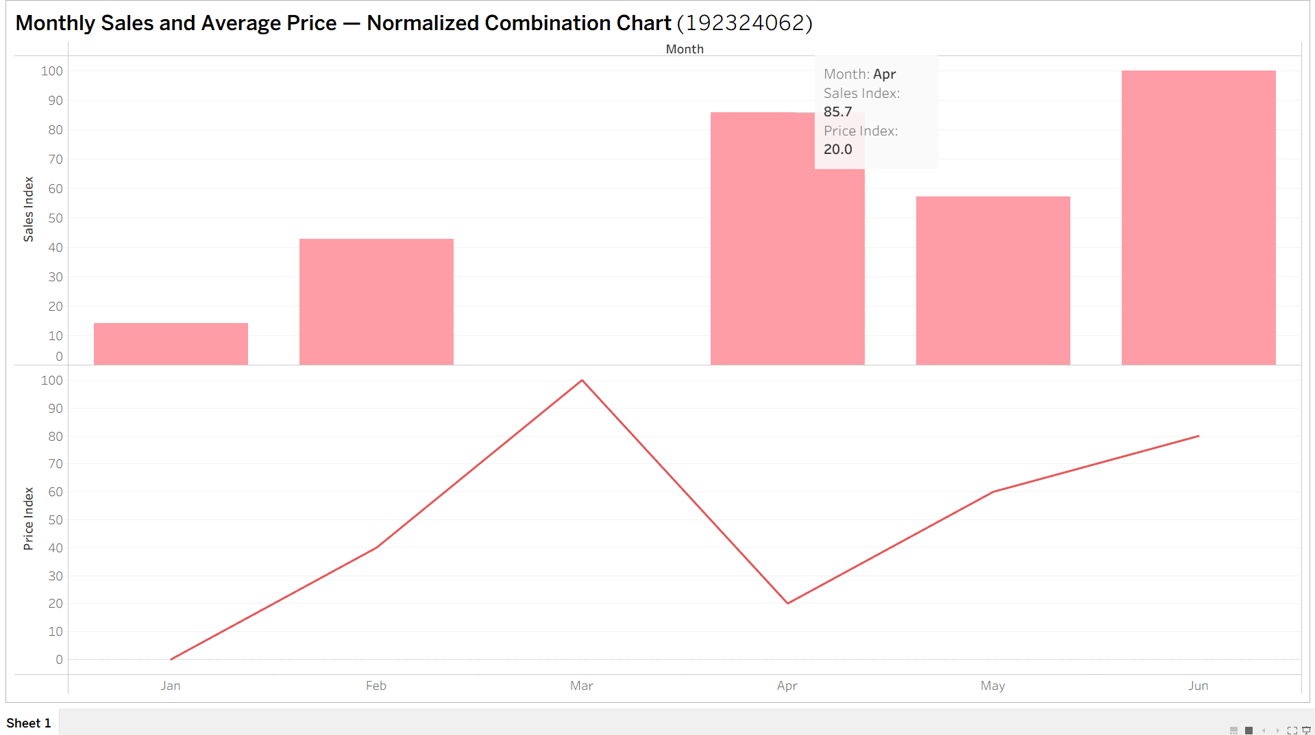
Problem 25 — Small Multiples Construction (5 Marks)
Data: Weekly sales (units) for 4 regions over 4 weeks: Region A: 40, 55, 50, 65 Region B: 30, 35, 45, 40
Region C: 60, 58, 70, 75 Region D: 20, 25, 22, 30
Task: Construct a set of four small-multiple line charts, one per region (rather than one overlaid chart),
and briefly justify this design choice over a single combined chart.
Data
Week | Region A | Region B | Region C | Region D
Week 1 | 40 | 30 | 60 | 20
Week 2 | 55 | 35 | 58 | 25
Week 3 | 50 | 45 | 70 | 22
Week 4 | 65 | 40 | 75 | 30
Tableau steps
- Connect the Excel dataset.
- Open a new worksheet.
- Drag Week → Columns.
- Drag Measure Values → Rows.
- Change Marks → Line.
- Drag Measure Names → Filters.
- Select:
  - Region A
  - Region B
  - Region C
  - Region D
- Drag Measure Names → Rows or use it as a row/column pane to create separate panels.
- Ensure each region has its own line chart.
